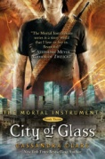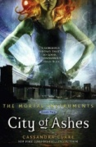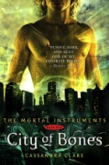 Wish List

Books

* Mortal Instruments Series; Cassandra Clare
  + City of Bones
  + City of Ashes
  + City of Glass
  + [Three more in progress]
* Infernal Devices Series (Prequels); Cassandra Clare
  + 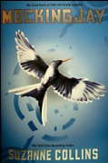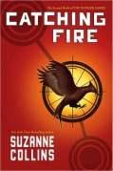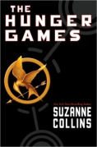Clockwork Angel
  + [Two more in progress]
* Hunger Games Series; Suzanne Collins
  + Hunger Games
  + Catching Fire
  + 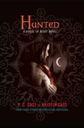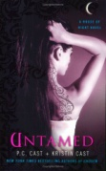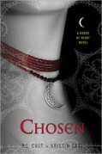Mockingjay
* House of Night Series; P.C. Cast and Kristen Cast
  + Betrayed
  + Chosen
  + Untamed
  + 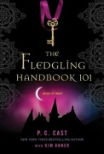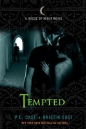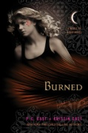Hunted
  + Tempted
  + Burned
  + Fledgling Handbook 101
  + 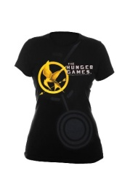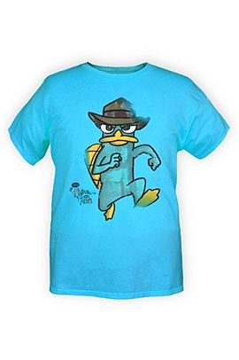[More to come]

Clothes

* Hunger Games Shirt [M]
* SVSU Sweatpants
* Perry the Platypus Shirt (Hot Topic[S])

Shoes

* Nike Shox [9]

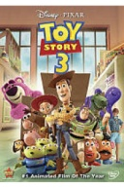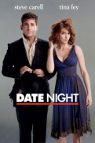Movies

* Date Night
* Law Abiding Citizen
* Toy Story 3